**Abstract**

The business value lies under a fact that how the organization is providing its service to the customer. The targeted audience are the customers which determines whether the business is growing or falling. In case of Real Estate System, it is very necessary to keep track of their business product and customers including all other asset. The adaption of information and communication technology has boosted almost every business and hence when it comes to achieving business goal through the use of technology the data is the precise factor that needs to be considered. A small piece a data can determine where the business grows or falls. So, the proposed project is about conducting a research on managing the data with the use of information and communication technology and thoroughly applying the result of result to develop a system that visualizes and represent the result of the research enhancing the decision-making capacity for real estate system. So, the project is semi research and semi development which follows a prototyping model using oracle 11g Enterprise database as core technology. The research would be conducted based on the data collected of certain real estate system and what is the current situation of data management in real estate sector and what further technique could be implemented so that business can be grown to a certain height than its current state. It also enhances security of data related to every asset of certain real estate organization with focus on increasing performance and better decision making with different visualization of collected data.

# **Introduction**

The development of information and communication technology is changing the way the people and business communicate. Everything is being transferred and revolutionized to a virtual world and also the way information being collected, deployed and dispatched have been changing rapidly. Data is more valuable than any other economic asset and business today consider data as new economy asset.

Business provides services to customers thus terabytes of data is being gathered every second. Data have been a profound favor for any business product so different techniques should be applied to managed the data to give flow to the business.

Techniques implied to control the data that have been collected, stored or processed as per the requirement of the business is known as data management. Data management techniques helps the business to be cost effective, competitive and assist in taking better decision and Inevitably provides an effective lifecycle for the business and a high edge to stand on the global market.

Data storage, data backup, data security, data validation, data verification, data entry, updating the data, archiving the data, data availability and many other are the common elements of data management techniques. All the incoming data such as text, video, graphs, sounds, images and other data formats needs to be managed and platform is needed based on the business size and requirement. For managing such data there are different computer software ranging from spread sheets packages, different data entry program to commercial enterprise DBMS (Database Management System).

A small piece of data holds a high business value. While capturing the data related to real estate business and its sectors, personal information of various peoples like clients, staffs of the organization are also collected as well. Such data may contain like economic details, bank account details, mental and physical health details that they don’t want to share with any third person. These data may exploit them or their professional and personal life if any unauthorized person gets their hands on. Information related to organization and many other factors are there to consider which may affect the business or organization if this information is not managed properly or if it gets leaked.

So, the proposed system is about analyzing and studying different techniques used for managing the data and adopting appropriate techniques for managing the data in a Property Market Real estate system.

# **Research Question**

What are the current techniques followed to manage the data in a Property Market Real Estate System?

Does adaption of appropriate data management techniques ensure data security, better decision making, increases performance and helps in growth of business in Property Market Real Estate System?

# **Mini Literature Review**

A literature review is a thorough study of all the materials related to the topic till now. Before beginning our research, we first need to go through all the related topic of previous research conducted by other researchers and eventually these finding turn into literature review for us. These gives the idea of what are the finding and limitation gained through the research till date and what further process need to be followed to achieve something new.

In a research report (Bardhan, Ashok & Jaffee, Dwight & Kroll, Cynthia, 2000) published by ‘**Fisher Center Research Reports’** in the year 2000 it has been estimated that over 300 million members are part of internet who could be found online at a daily basis. While the sales through the internet has been increased by 50% over the last few years. The change in information technology has evolved the market in Real estate and millions and billions of bytes of data are being transferred each day but the study shows that people are only busy buying and selling the real estate property while these data are left unmanaged. Such data could be managed with proper implementation of data management technique which is the core purpose of this research.

Similarly, a research conducted in a Volvo group truck Operations (Martin O. Enofe, 2017) , the published report shows that the current state of data analysis in the product realization process of Volvo group truck operations on how data is made available and used in the engineering phase and in assembly line phase but there is not standard approach followed on how data is being managed in within different levels of organization. When the result through the research is being applied in their engineering and manufacturing department, the production line got risen up by 20% and is in the phase of increasing. The research result was to follow standard for managing data thus it supports the research the is going to be conducted in this project.

# **Problem statement**

Data is the new fuel and analytical engine that drives the business for most of the recent generation companies. Every companies cannot imply appropriate techniques to manage the data as per the requirement of their business. Shortage of storage, loss of data, unavailability of data, security issue, invalid data, unverified data, data backup, updating the old data, data duplication are the general issues that business generally fails to adopt and thus they fall back. The theme behind this analysis and study, is to formulate a solution on where and how a business can apply such technique. For this analysis, an appropriate platform that can be employed for managing the data is oracle enterprise 11g DBMS which can address all these underlying issues with the use of techniques like sql loader, data pumping for bulk data insert, using RMAN and flashback for data backup and recovery, using ASM for data storage and disk failures and data availability, performing database auditing, implementing multiple user authentication for security purpose by providing roles and privileges and many other associated techniques could be applied for proper data management.

Company core values lies under the data and thus it should be highly prioritized and focused. Following diagram shows how a company relying on data may encounter with the problem and issues related to data. (Adobe.com-photoshop, 2019)

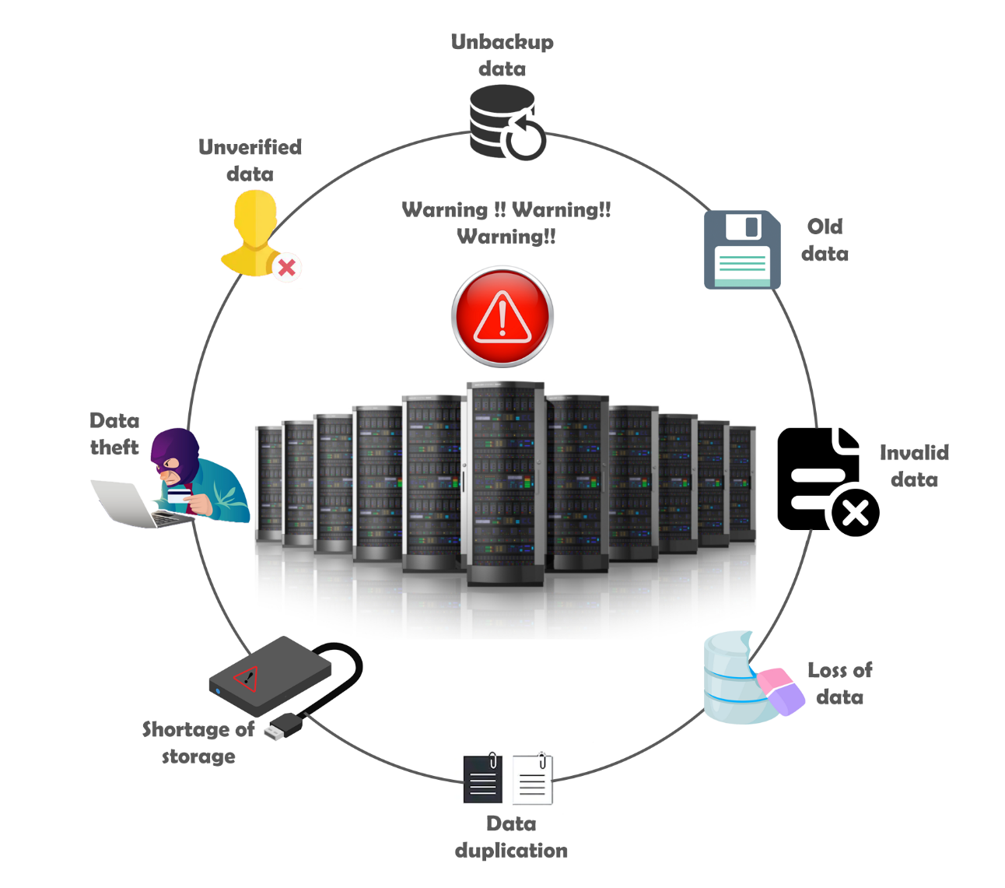

Figure :Problem-and-issues-in-a-company-data(1)

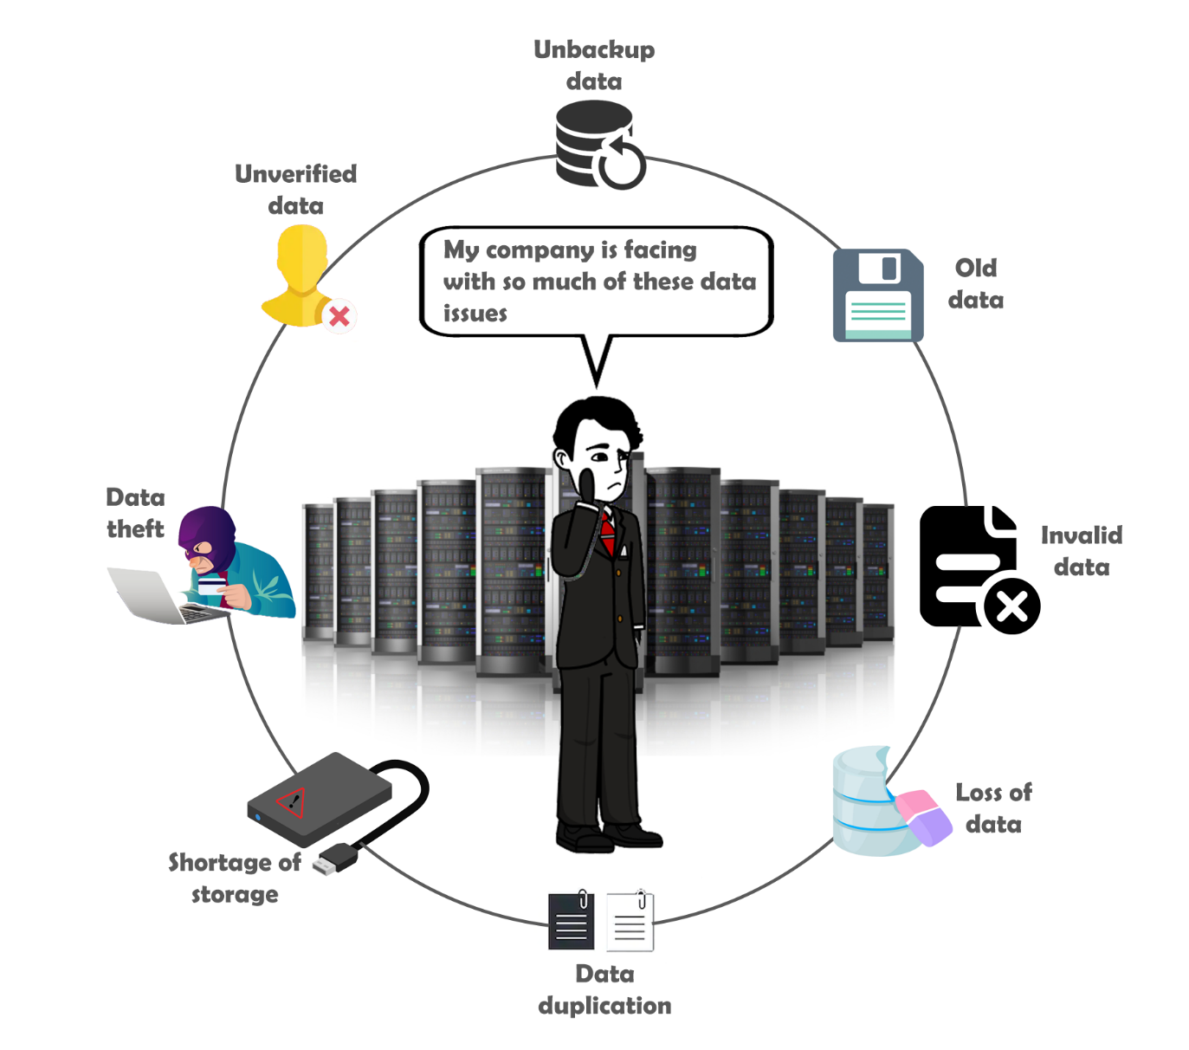

Figure :Problem-and-issues-in-a-company-data(2)

These two diagrams above shows how a company can face the issues related to data. The first figure demonstrates the issues like data theft, shortage of storage, data duplication, loss of data, invalid data, old data, unbacked data, unverified data. These are the issues a company faces when it fails manage the data properly and such factors are responsible for dragging out the value from the business resulting in unbearable loss. So, solution needs to be formulated.

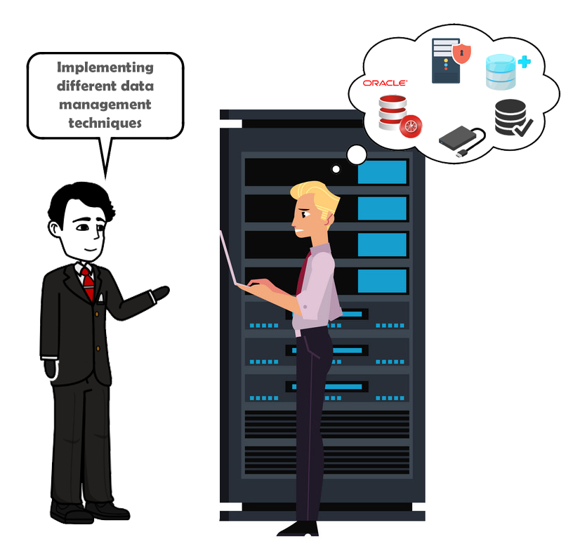

Figure :Implementing -appropriate-data-management-technique

Similarly, the figure above shows implementing an appropriate technology that could flush out the issues that arrived before. Here the company chooses to implement oracle DBMS which provides all the necessary functionality to resolve the issues faced by the company.

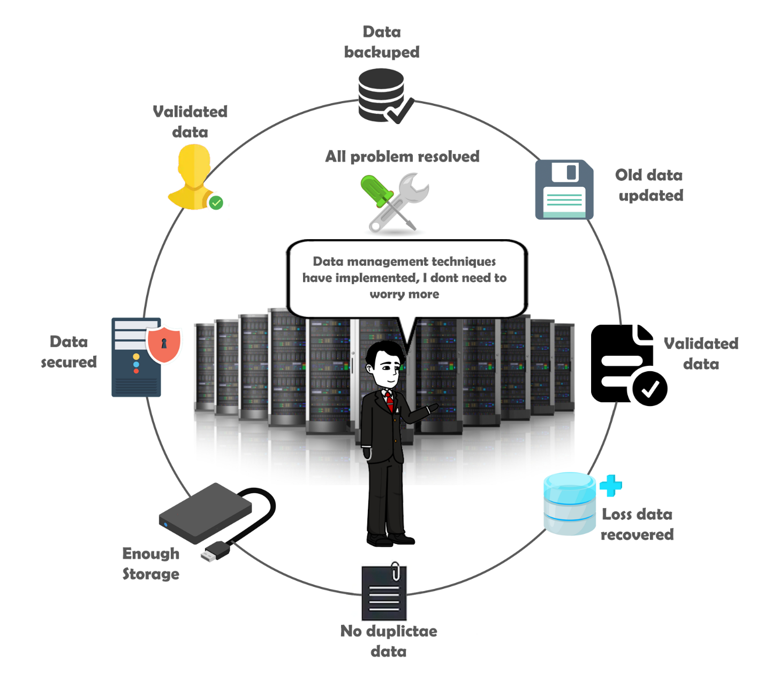

Figure :Issues-and-problem-resolved

On adopting appropriate technology, the company seems to have got rid of the issues and finally they can focus on improvising the business to achieve their destined goal.

# **Aim**

The study of this topic is carried out in an academic scale. So, the aim of the project is to practically explore the different data management technique and how it can be applied in a Property Market Real estate system so as to help in better decision making and keep the business in track.

# **Objectives**

* To search different document and papers that adds support to the research.
* To choose an appropriate technology to represent the outcome of the research.
* To add quality attributes to the chosen technology for better understanding of the result achieved through research.
* To enhance and develop skills for decision making with proper analysis.
* To manage time for each step taken to perform research and consequently learn time management skills.
* To perform survey, observation, questionnaire with proper communication and hence develop the communication skill.
* To complete the research at defined deadline
* To prepare a well written document of research project
* To include all the knowledge covered throughout the academic course.
* To learn to use different tools and technology of project management.
* To develop professional skills to work in a real field.
* To collect appropriate data of a related real estate system.
* To choose an appropriate operating system that supports for the implementation of tool used to deliver research result.
* To create an appropriate DMBS in an oracle 11g and implement it to plot the result of the research
* To use ASM technique for allowing the database system to manage the disk storage automatically.
* To perform ETL (Extraction Transformation and Loading) techniques to load and transfer large amount of data into the database.
* To create different user profile with high password complexity and privileges for maintaining security.
* To use advanced SQL query to minimize the system load and reduce the memory optimization.
* To create view, indexes and perform query rewrite technique for faster retrieval of data.
* To use FDA (flashback Data Archive) for longer storage of undo data and RMAN (Recovery Manager) for data backup and recovery.
* To create a working system for a real estate system.
* To use analytical tool like tableau to perform visual analytics of data for better decision making.

# **Scope and technical challenges**

## **Research Framework**

A framework is a procedure needed to undertake in order to develop a product and perform a research. As there are number of frameworks to start with but the suitable framework for the proposed research is a prototype model.

### **Prototyping model**

The main idea behind the prototyping model is to prepare a dummy model of a product or a final outcome that initializes basic functionality that a system is going to consume at the end. This may be considered as a throwaway model that is built in order to understand how a product looks and feels like and also helps in understanding the requirements that a project is going to address. For a successful outcome through a prototyping model, following steps needs to be followed.

* **Project Initiation**
* **Requirement identification and analysis**
* **Design and build prototype**
* **User evaluation of the designed prototype**
* **Engineer a prototype into product**
* **Test and refine the product**

### **Justification of use**

In context of a research project, it may include the requirements that are unclear at the initial phase and keeps changing over time and chances of error detection are probable at every stage. On a practical basis, scope of the project may expand afterward and the initial plan may not be considered as final. Test result may exclude previously included requirements and some new functionality or requirements may be added as well. Thus, a prototype model is preferred to be used in the proposed project which iteratively identifies the changing factors and addresses most of these factors that may get stepped in in the project.

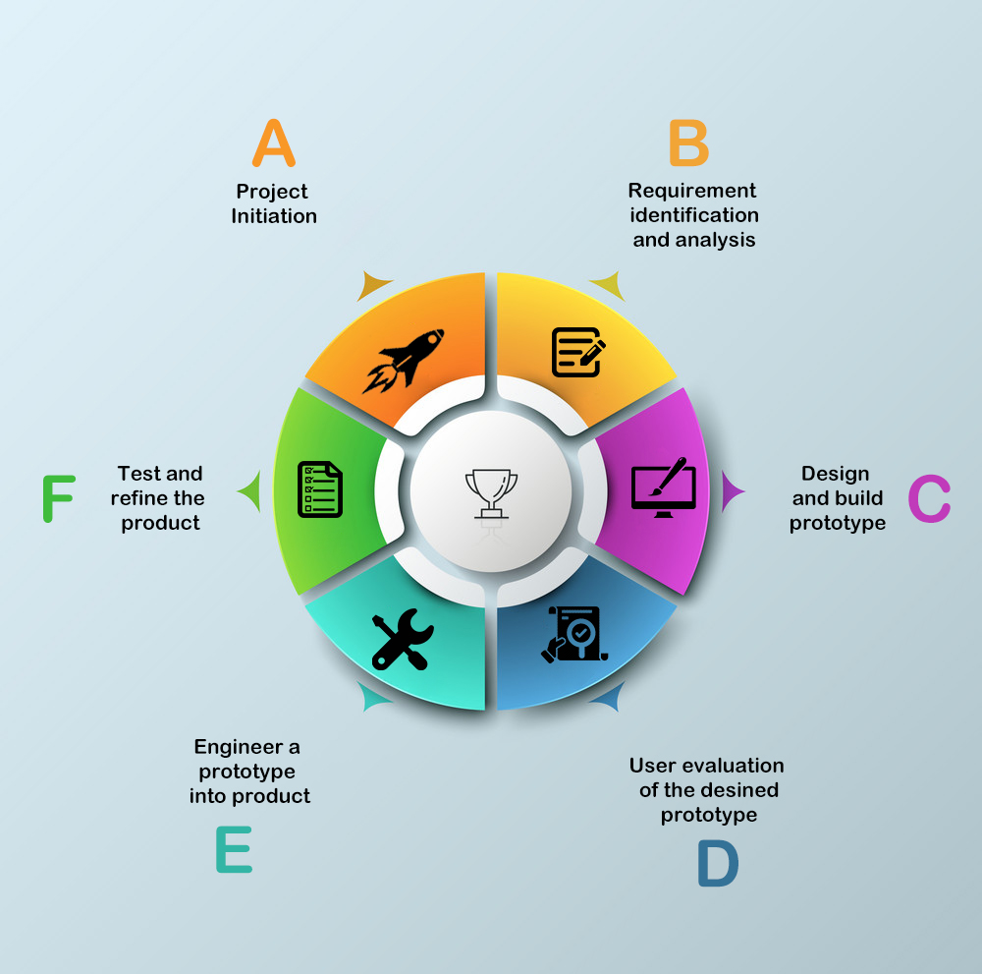

Figure :Project-framework (prototyping model)

## **Tools**

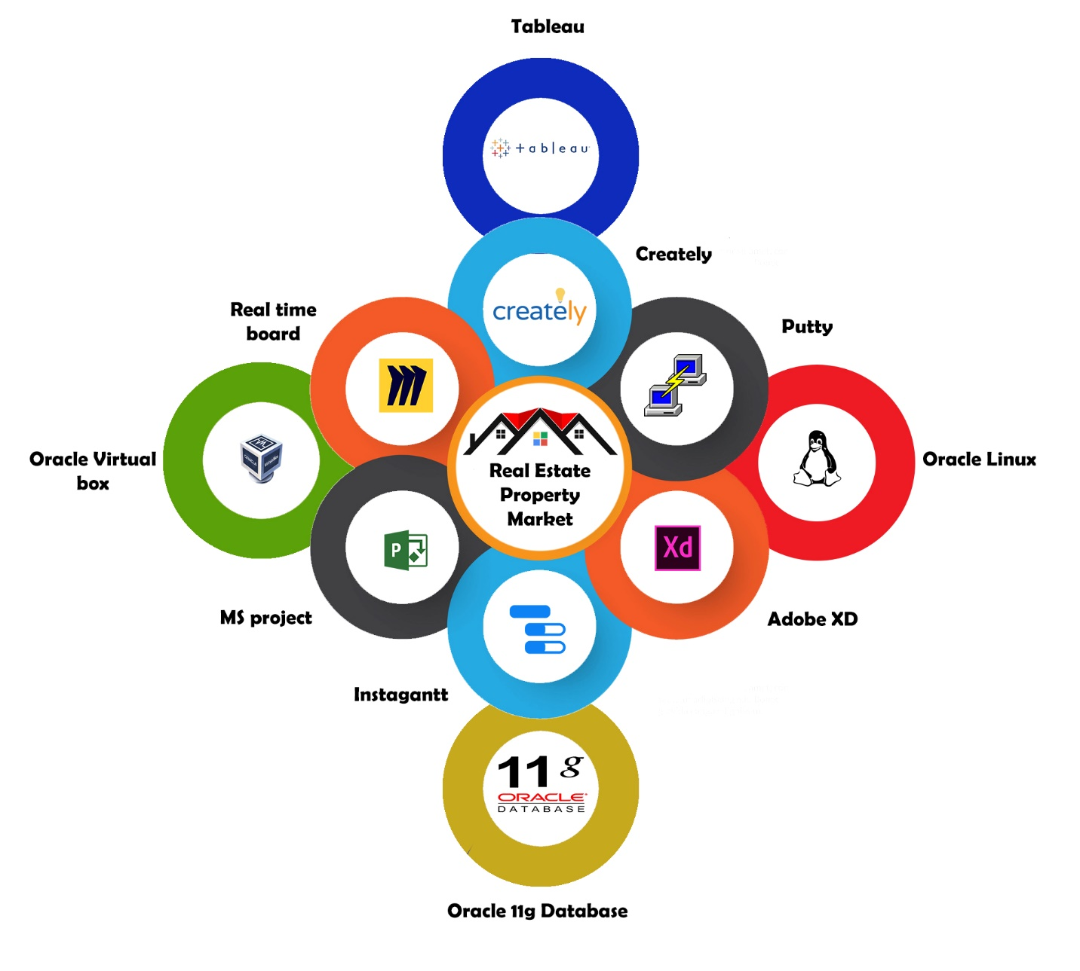

Figure :Tools-used-in-the-system

## **Technology**

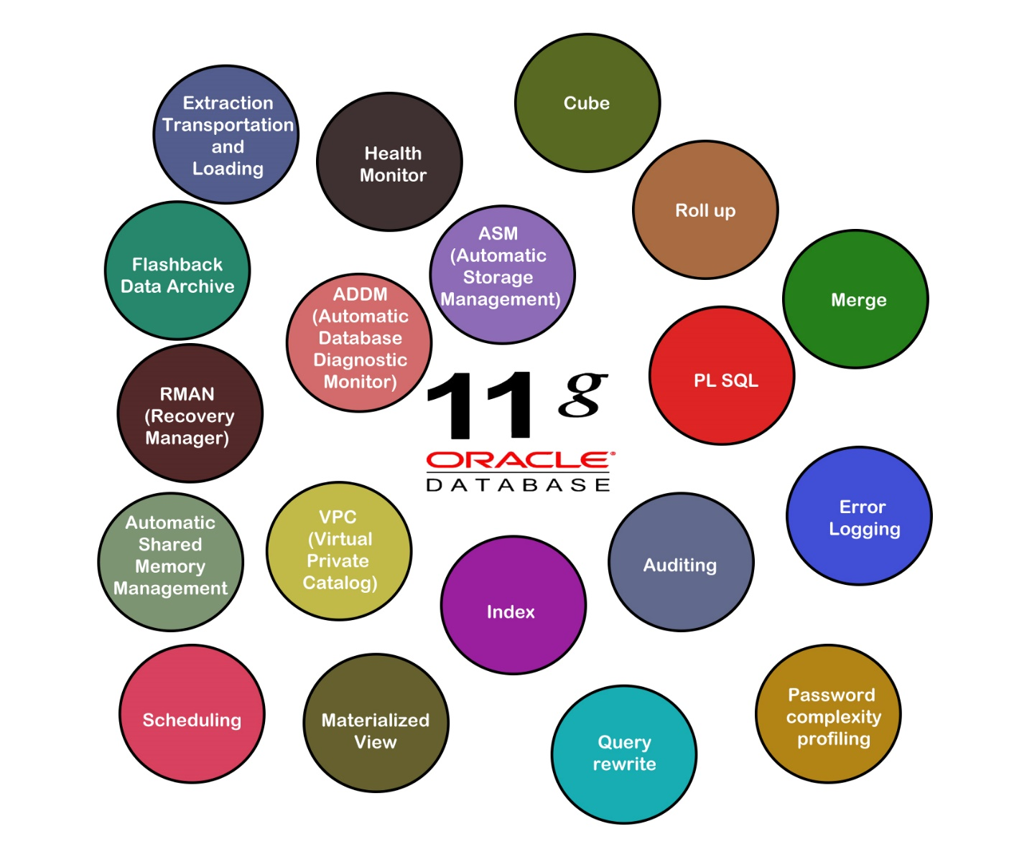

Figure :Technology-involved

# **Project deliverables**

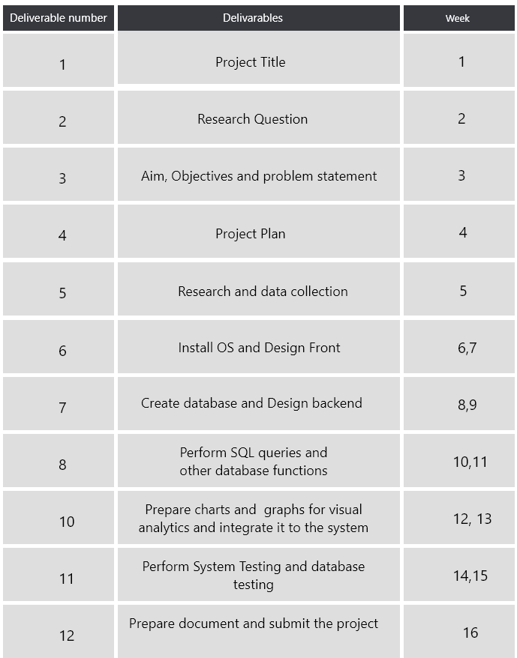

Figure :Deliverables

# **Estimated Outcomes**

The proposed project is a research project with a computing system to support the result of the research. So, the estimated outcomes are divided in two halves. The first outcome provides the result of the research question where as the working software represents how the result of the research can be implemented into a Property Market Real estate system. The main supporting factor for the software would be a database where a number of quality attributes are included whose primary purpose is to include necessary technique and technology for data management which would be provided by the database itself. The frond end part of the system depicts different visualization graphs and charts keeping track of business and also supporting for making the decision. In general, the estimated outcomes include finding of research plan, implementation of different data management technique with database and a analytical system representing the necessary visualization of graphs and charts.

# **Project Plan**

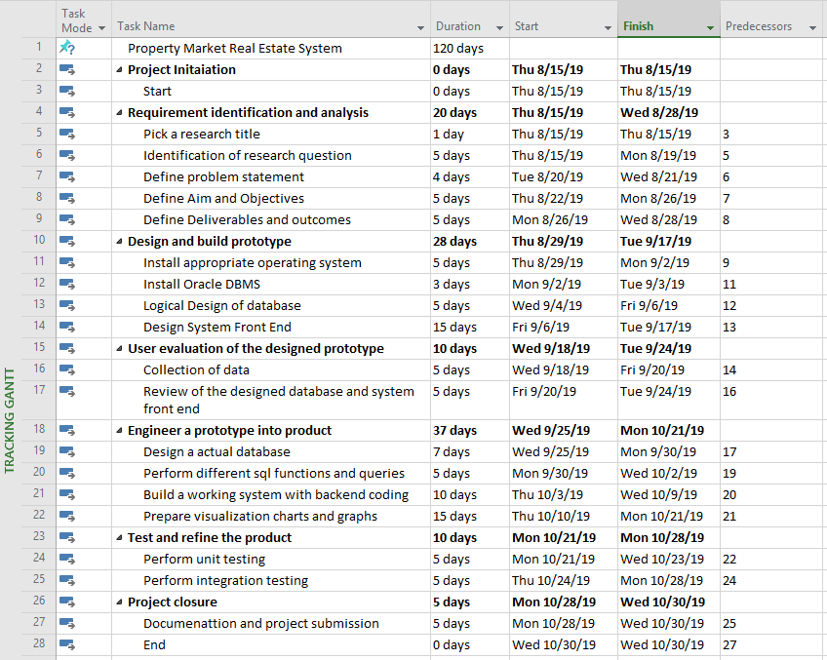

Figure 9:Project-plan

## **Project Timing**

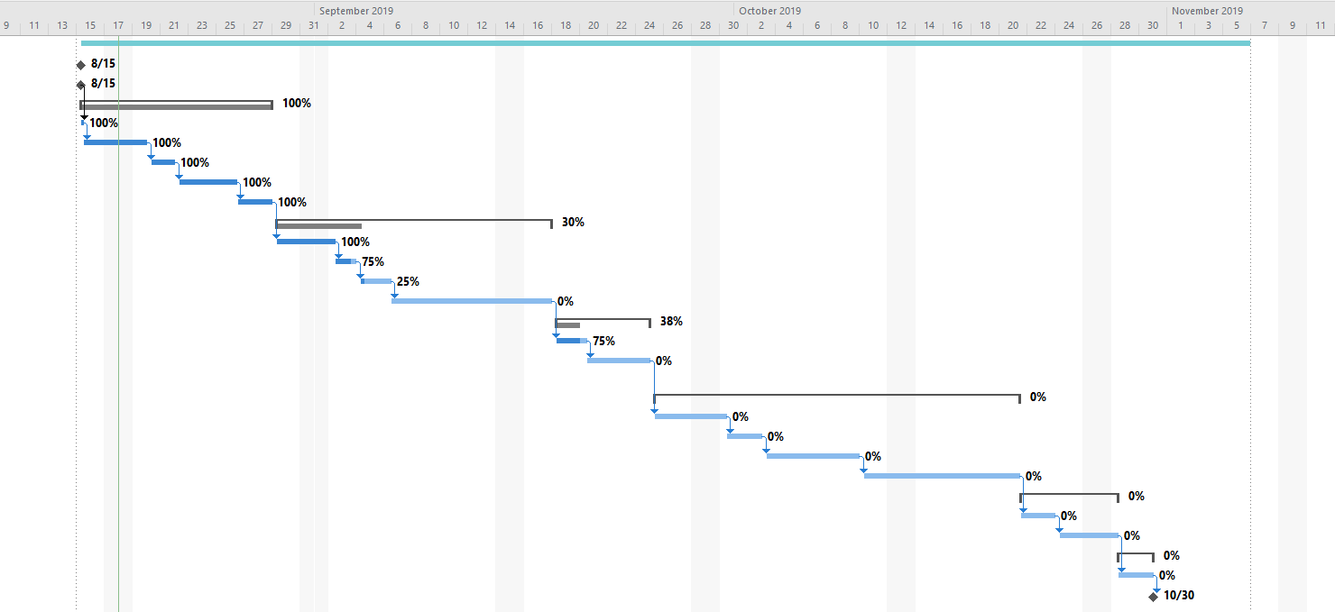

Figure 10:Gantt-Chart

# **Risk Register**

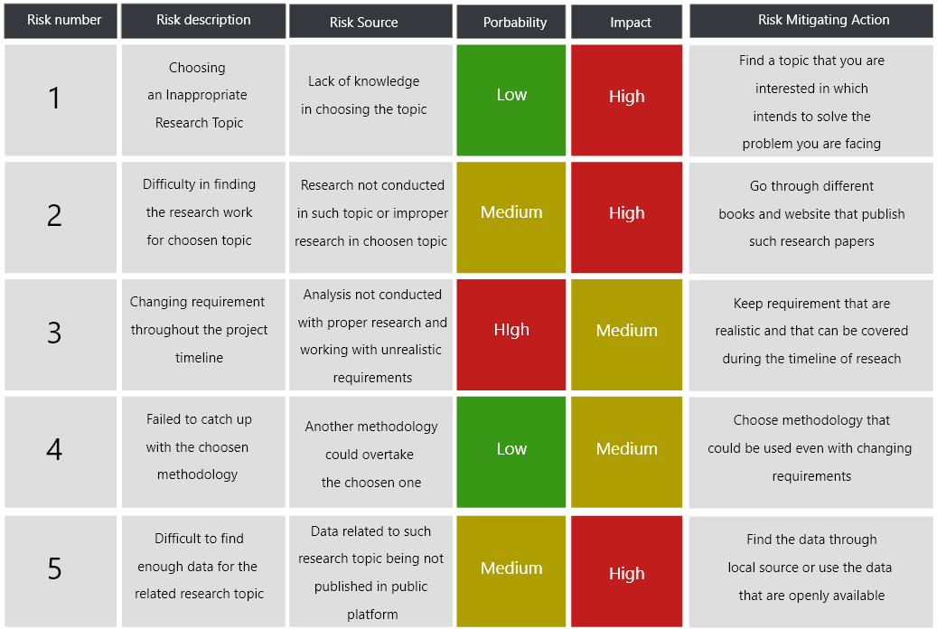

Figure :Risk-register

# **Conclusion**

To recapitulate, the proposed project is a semi research and semi development project. The research is conducted in an academic basis on a various data management technique and develop a system which demonstrates visualization of data collected which acts as a decision support system as well. The system is developed so as to support the result of the research while the core technology supporting the research would be enterprise oracle 11g database Property Market Real Estate system where the framework or the methodology would be a prototyping model. Thus with this research the main aim is to practically explore the result of research through implementation in a Real Estate System.